Project Setup (15 minutes)
- Install Git: Ensure Git is installed on your system. Verify with git --version.
Set Up Git: Configure your Git username and email:
git config --global user.name "Your Name"
git config --global user.email "your.email@example.com"

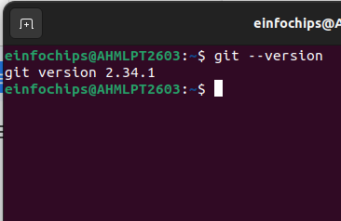

- Create a GitHub Repository:
  - Go to GitHub and create a new repository named website-project.
Clone the repository to your local machine:
git clone https://github.com/your-username/website-project.git

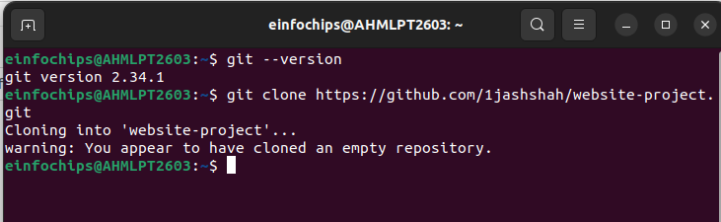

- Initialize the Project:
Navigate to the project directory:
cd website-project

Create initial project structure:
mkdir src
touch src/index.html
echo "<!DOCTYPE html><html><head><title>My Website</title></head><body><h1>Welcome to my website!</h1></body></html>" > src/index.html

Commit and push the initial project structure:
git add .
git commit -m "Initial commit: Added project structure and index.html"
git push origin main

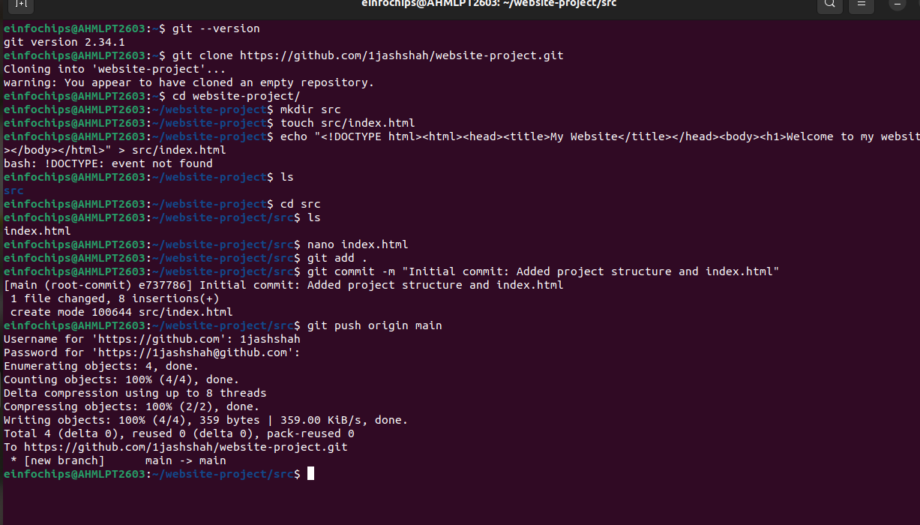

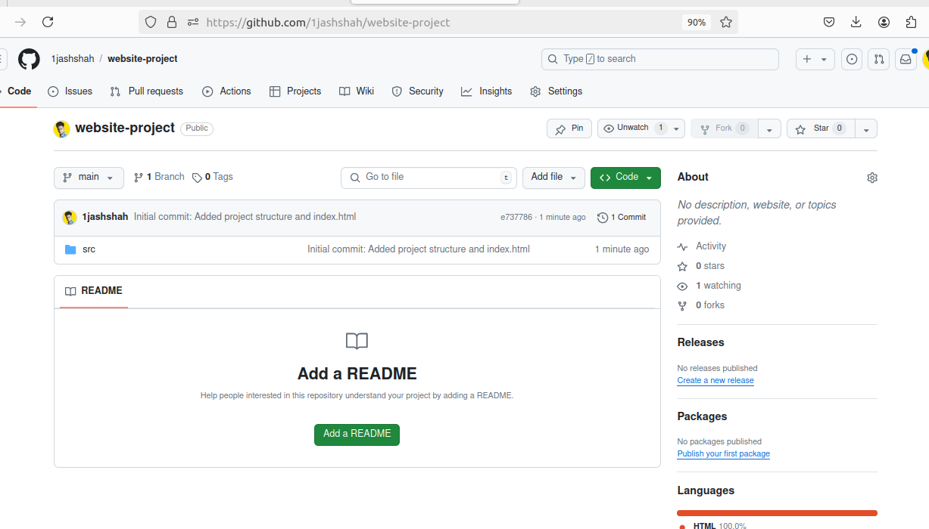

Exercise 1: Branching and Adding Features (20 minutes)
Create a New Branch for Blog Post Feature:
git checkout -b feature/add-blog-post
git checkout: This command is used to switch branches or restore working tree files.
- -b: This option tells Git to create a new branch before switching to it.
- feature/add-blog-post: This is the name of the new branch being created.
- Add a Blog Post Page:
Create blog.html:
touch src/blog.html
echo "<!DOCTYPE html><html><head><title>Blog Post</title></head><body><h1>My First Blog Post</h1></body></html>" > src/blog.html
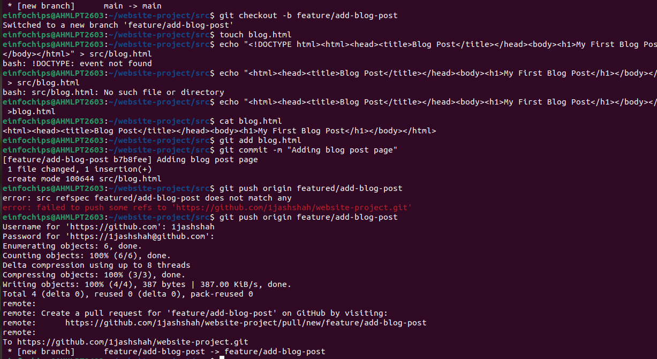

Commit and push changes:
git add src/blog.html
git commit -m "Added blog post page"
git push origin feature/add-blog-post
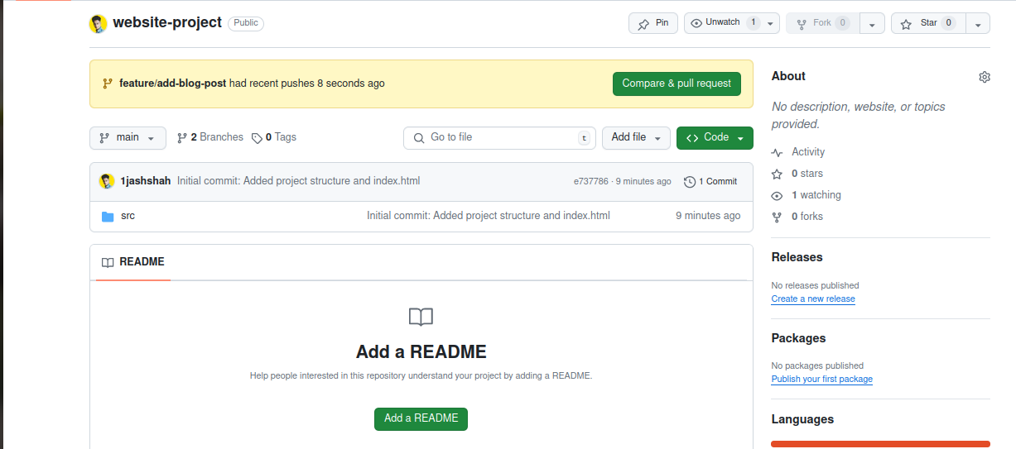

Exercise 2: Collaborating with Merging and Handling Merge Conflicts (25 minutes)
Create Another Branch for Author Info:
git checkout main
git checkout -b feature/add-author-info

- Add Author Info to Blog Page:
Modify blog.html:
echo "<p>Author: John Doe</p>" >> src/blog.html
Commit and push changes:
git add src/blog.html
git commit -m "Added author info to blog post"
git push origin feature/add-author-info
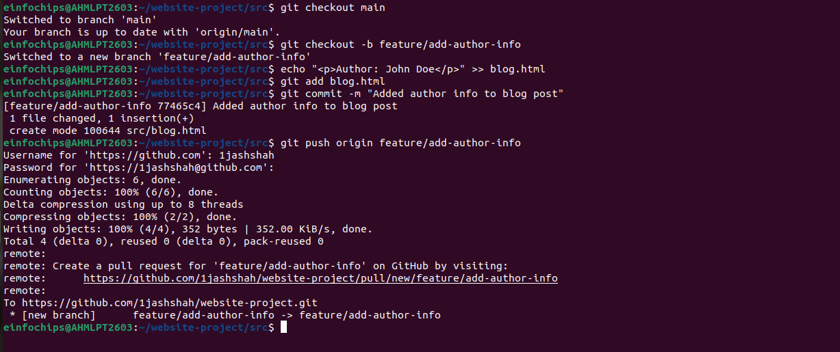
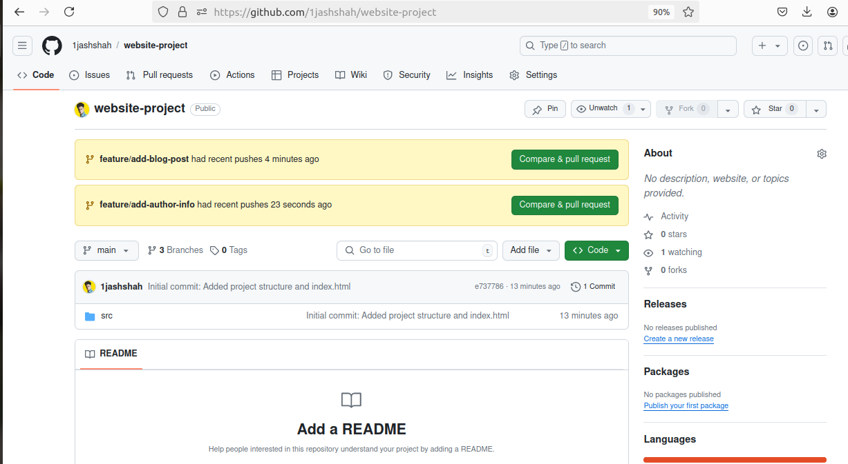

Create a Merge Conflict:
Modify blog.html on the feature/add-blog-post branch:
git checkout feature/add-blog-post
echo "<p>Published on: July 10, 2024</p>" >> src/blog.html
git add src/blog.html
git commit -m "Added publish date to blog post"
git push origin feature/add-blog-post
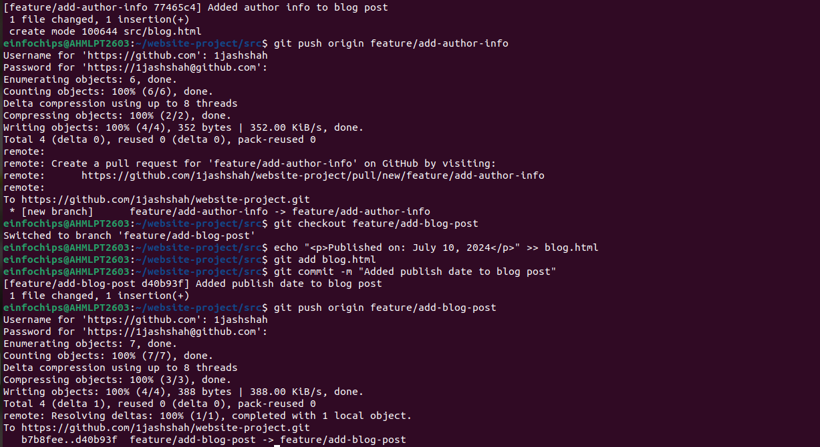

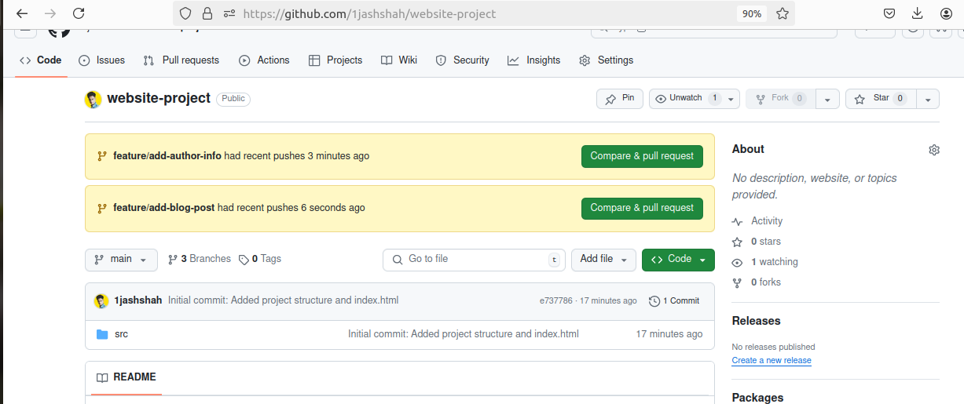

Merge and Resolve Conflict:
Attempt to merge feature/add-blog-post into main:
git checkout main
git merge feature/add-blog-post
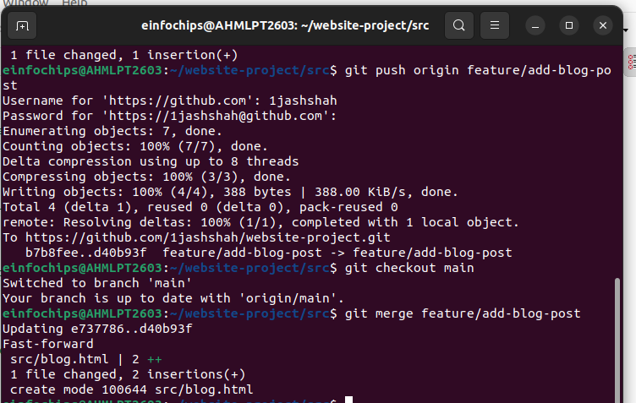
Resolve the conflict in src/blog.html, then:
git add src/blog.html
git commit -m "Resolved merge conflict in blog post"
git push origin main
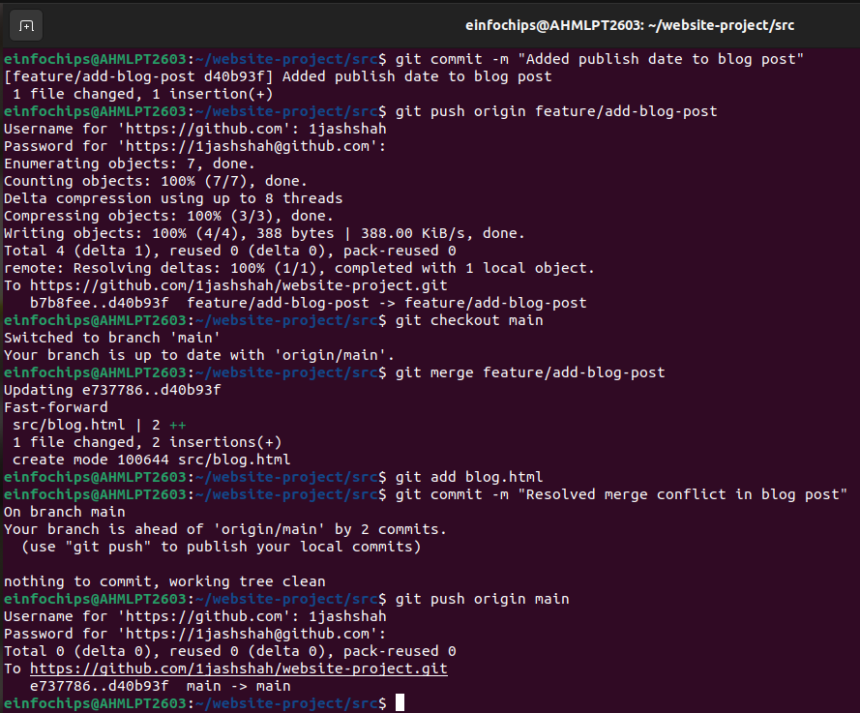

Exercise 3: Rebasing and Feature Enhancement (25 minutes)
- Rebase a Branch for Comment Feature:
Rebase feature/add-author-info onto main:
git checkout feature/add-author-info
git rebase main
- Resolve any conflicts that arise during rebase.
- Add Comment Section:
Modify blog.html to add a comment section:
echo "<h2>Comments</h2><p>No comments yet.</p>" >> src/blog.html
git add src/blog.html
git commit -m "Added comment section"
git push origin feature/add-author-info

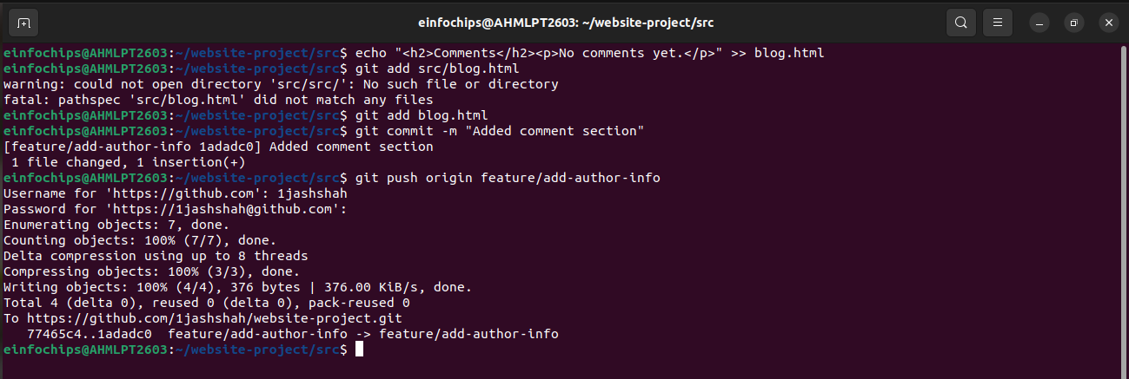

Exercise 4: Pulling and Simulating Collaboration (20 minutes)
- Pull Changes from Remote:
Ensure the main branch is up-to-date:
git checkout main
git pull origin main

- Simulate a Collaborator's Change:
  - Make a change on GitHub directly (e.g., edit blog.html to add a new comment).
- Pull Collaborator's Changes:
Pull the changes made by the collaborator:
git pull origin main

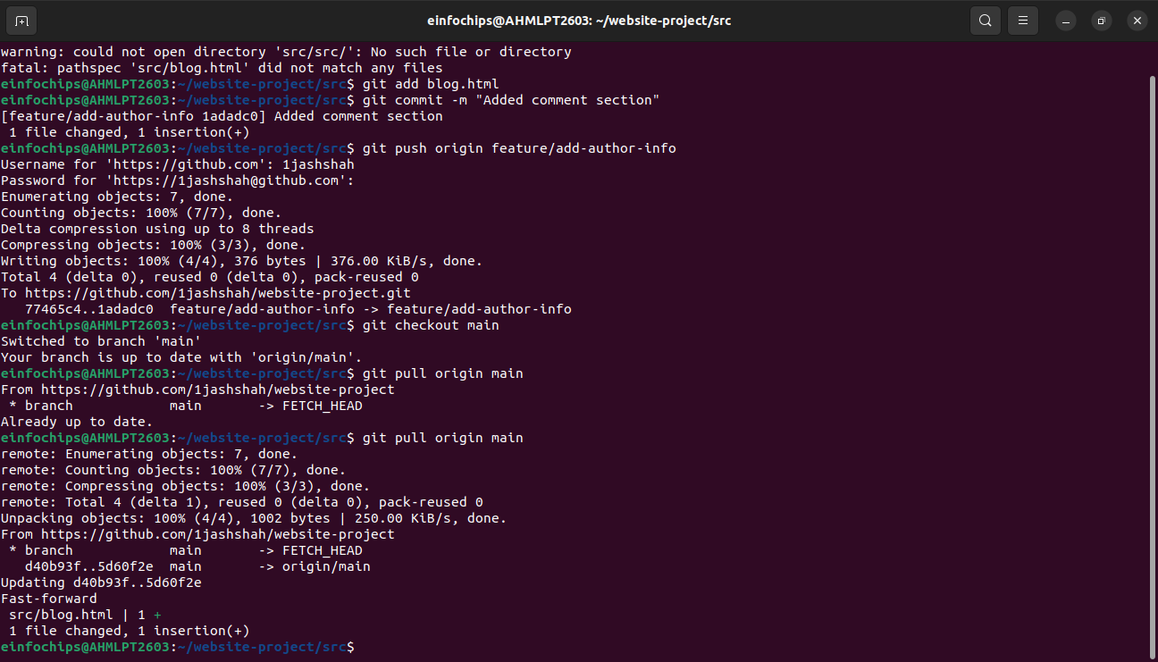

Exercise 5: Versioning and Rollback (30 minutes)
- Tagging a Version:
Tag the current commit as v1.0:
git tag -a v1.0 -m "Version 1.0: Initial release"
git push origin v1.0
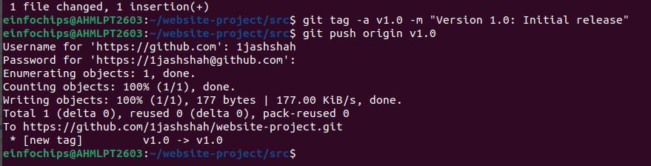
- Make a Change that Needs Reversion:
Modify blog.html:
echo "<p>Incorrect comment</p>" >> src/blog.html
git add src/blog.html
git commit -m "Incorrect comment update"
git push origin main
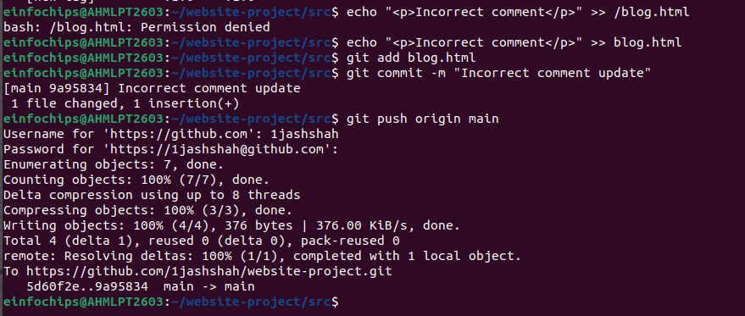
- Revert to a Previous Version:
Use git revert to undo the last commit:
git revert HEAD
git push origin main
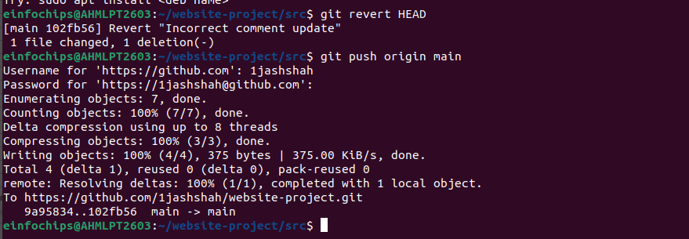
Alternatively, reset to a specific commit (use with caution):
git reset --hard v1.0
git push -f origin main
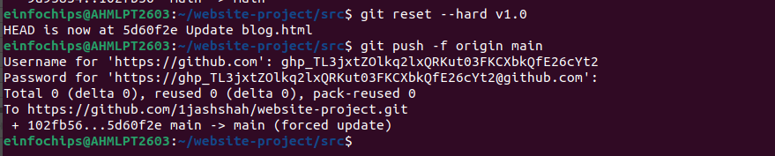

Extra Activities (25 minutes)
- Stashing Changes:
Make some local changes without committing:
echo "<p>Uncommitted changes</p>" >> src/blog.html
Stash the changes:
git stash
Apply the stashed changes:
git stash apply
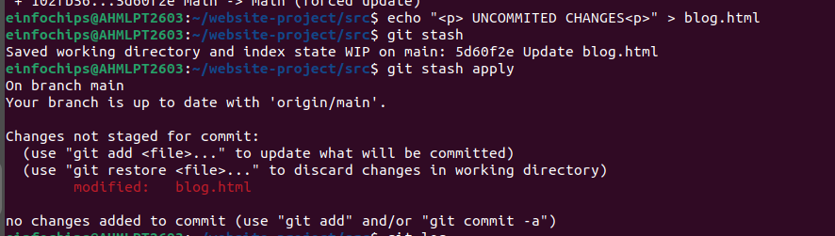
- Viewing Commit History:
Use git log to view commit history:
git log –oneline
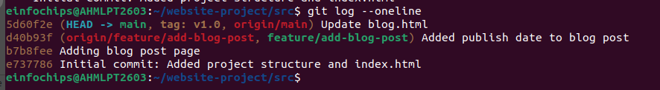

- Cherry-Picking Commits:
Create a new branch and cherry-pick a commit from another branch:
git checkout -b feature/cherry-pick
git cherry-pick <commit-hash>
git push origin feature/cherry-pick
- Interactive Rebase:
Use interactive rebase to squash commits:
git checkout main
git rebase -i HEAD~3
